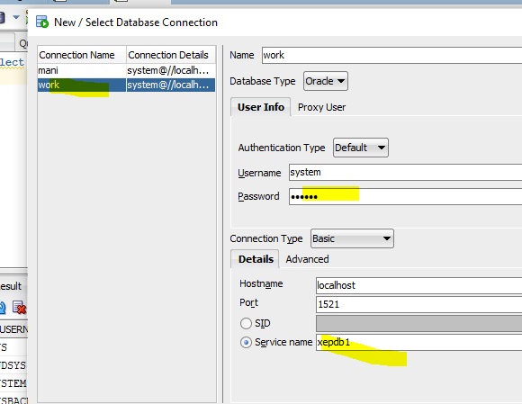

Give scservice name as XEPDB!

If u r unable to connect then change the name to XEPDB1 From XE in tnsname.ora file

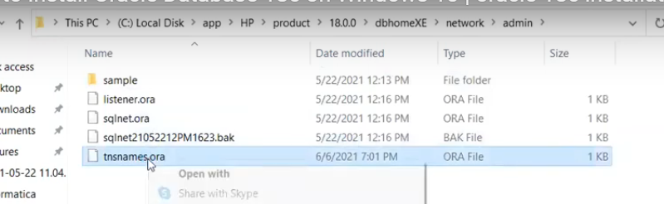

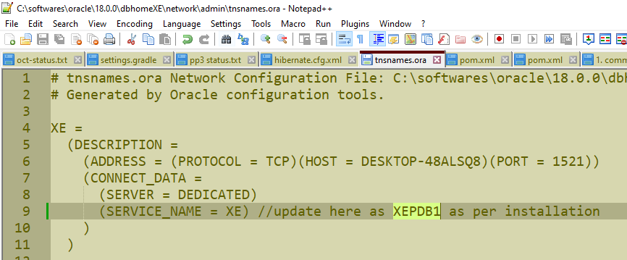

Unlocking HR account

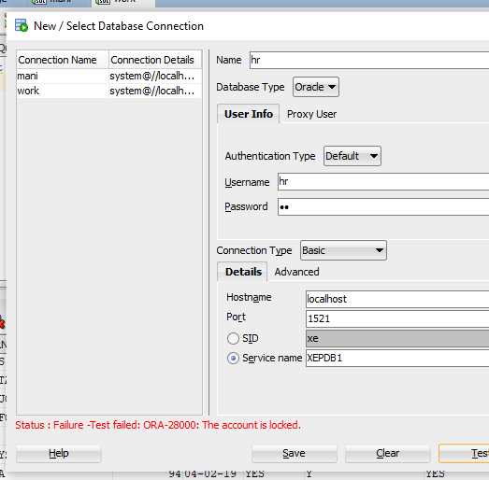

Initially HR account will be locked we just need to unlock by using the below query

HR is a separate schema (space) which have diff tables

Alter user <username> identified by <password> account unlock // here we are unlocking by creating a default password

alter user hr identified by hr account unlock

with above hr space will be unlocked

## shortcuts

to execute that line no need to select, just press ctrl+enter

or select +f5